Joe Stetzer

Joestetz@gmail.com

Abstract

This document will give a reader with little experience of managing a website the information required to maintain the Keystone Soccer Academy website.

Keystone Soccer Academy

Website Administrator’s Quick Guide

Contents

Security 2

Hosting Account 2

WordPress Administrator 2

Strong Passwords 2

Logging in/out 2

Making page modifications 3

Option 1 – Administrator Interface 4

Option 2 – While Browsing 5

Adding images for use throughout the site 5

Add Media 5

Updating the homepage news image slider 6

Adding Slides 6

Modifying Slides 8

Deleting Slides 8

Updating the calendar (upcoming events) 9

Adding Events 9

Modifying Events 10

Deleting Events 10

Updating announcements 11

Adding Announcements 11

Modifying Announcements 11

Deleting Announcements 12

Updating Forms 12

Modifying the image galleries (photos and uniforms) 13

# Security

Before you begin making modifications, you must first be logged into the website as an administrator. However, it is wise to understand that as an administrator there are some key considerations for keeping your site safe from outsider “threats” that can do harm to your site.

## Hosting Account

The highest level privilege for your site is the hosting account administrator. This account has the ability to control not only the content on your domains (keystonesoccer.net & keystonesocceracademy.net), but they could also potentially have access to your personal account information. With that in mind, only share your account information with trusted people and it helps to change the password often.

## WordPress Administrator

WordPress is a free, open source, content management system that is widely used on the web. It is a tool that makes managing your site easy while at the same time being extremely feature-rich. As with managing your hosting account, there is a WordPress administrator account that has access to everything within the walls of the content management system on your domain. It is also highly recommended to only share this account with trusted people and to change the password often.

## Strong Passwords

The definition of a strong password changes with time as technology evolves. Even though this site doesn’t contain sensitive materials, it is recommended to incorporate strong passwords to prevent unwanted tampering with your site that can cause significant downtime and headaches in the resolution process. The strong password of today should contain:

* At least 15 characters
* One or more uppercase letters
* One or more lowercase letters
* One or more numbers
* One or more special characters (such as *!@#$%^*)

In addition, the strong password should **not** contain:

* Your login name
* A dictionary word
* A common name
* A keyboard pattern (several characters in sequence on a keyboard such as qwerty or 12345)

I good process is to take a familiar word or phrase (without spaces) and substitute some characters from the ‘*should’* list from above. For example *Keystone Soccer* could become: *K3y$t0n3*$0cc3R*.

# Logging in/out

To log into your WordPress account, go to the URL: <http://keystonesoccer.net/wp-admin/>. You will be prompted with a login form where you should enter the administrator account’s username and password (hopefully utilizing a strong password as discussion previously). When logged in, you will see a top bar that distinguishes you from a normal site visitor as shown in Figure 1.

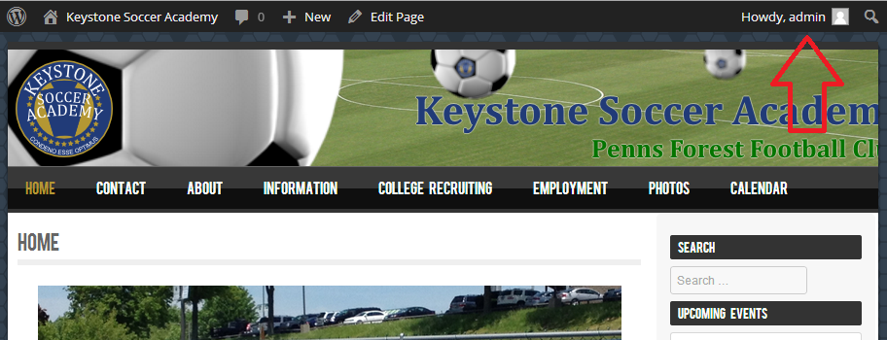

Figure 1 - Logged in

When your changes are complete, it is important that you remember to log out by hovering over the account name (admin) and clicking Log Out. This helps to maintain the security of your site and prevents a strategy called “session hijacking”.

# Making page modifications

There are several pages on the site that contain basic formatted text. These are the easiest components of your site to modify and there are two simple ways to accomplish the modification. Use Option 1 to update several pages and while already in the administrator interface. Use Option 2 to update a single page while browsing the site or if you are unfamiliar what the name of the page is from the administrator interface.

It is important to note that some pages contain something called a “shortcode” that looks like the following in the administrator edit screen:

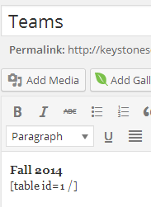

Figure 2 - Page with shortcode

The shortcode format is surrounded by square brackets [ ] and tells WordPress (your site) to do something special using a plugin on the site. Some plugins include a photo gallery, table, and image slider. If a page you are editing contains one of these shortcodes, please work around them and avoid removing or altering them. To alter the contents of one of these plugins, use a method detailed in one of the other sections in the guide.

## Option 1 – Administrator Interface

1. Navigate to the Pages menu and click “*All Pages*”.

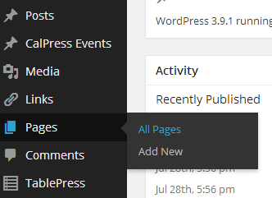

Figure 3 - View Pages

1. Click on the title of the page you wish to edit.
2. Edit the description as needed using the editor provided as shown in Figure 4.

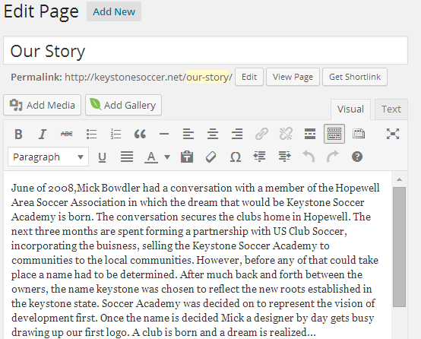

Figure 4 - Edit Page

1. When editing is complete, click “*Update*” from the top of the right sidebar.

## Option 2 – While Browsing

1. Navigate to the page you wish to edit using the top navigation while browsing your site (be sure you are still logged in as admin).
2. At the bottom of the page, you will see a link labeled “*Edit*”.

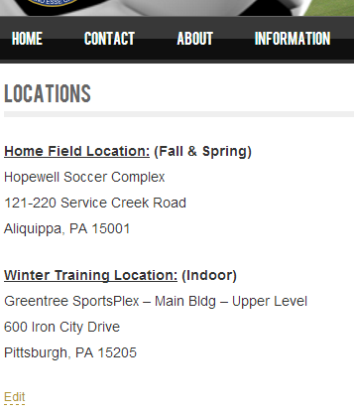

Figure 5 - Edit page from browsing

1. Click this link and follow the steps 3-4 from Option 1, above.

# Adding images for use throughout the site

Your site contains a media gallery used to upload pictures, videos, and other files that can be referenced in various places throughout the site. This is extremely useful for utilizing an image more than once while only having a single copy taking up valuable storage space on your site. It is recommended (but not required) to upload images here before using them elsewhere on your site. Whenever you want to reference an image in the image slider, a photo gallery, or just embedded on a page of your site, you know it’s located in the image gallery already.

## Add Media

1. Navigate to the Media menu and click “*Add New*” as shown in Figure 6.

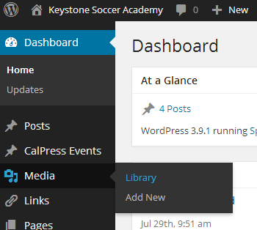

Figure 6 - Media Gallery

1. Drag and drop files from your computer onto the box with dashed borders.
2. You can also click the button labeled “Select Files” to browse from your computer.

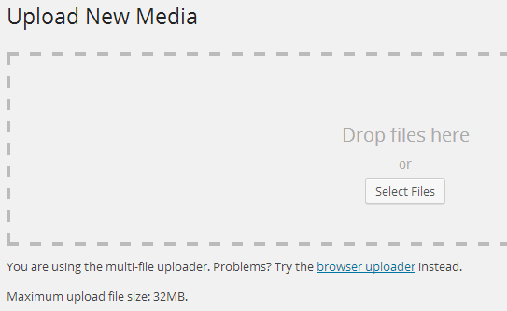

Figure 7 - Uploading media

1. Your files will automatically be uploaded once selected or dropped onto the page.

# Updating the homepage news image slider

Your site contains an image slider for news called “Master Slider”. This slider is located on the homepage of your site and will rotate between images every few seconds.

## Adding Slides

1. Navigate to the Master Slider menu and click “Master Slider”.

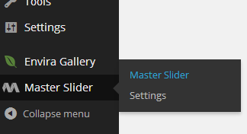

Figure 8 - Master Slider

1. Click on the “Homepage Slider”.
2. You should see an interface similar to the one in Figure 9.

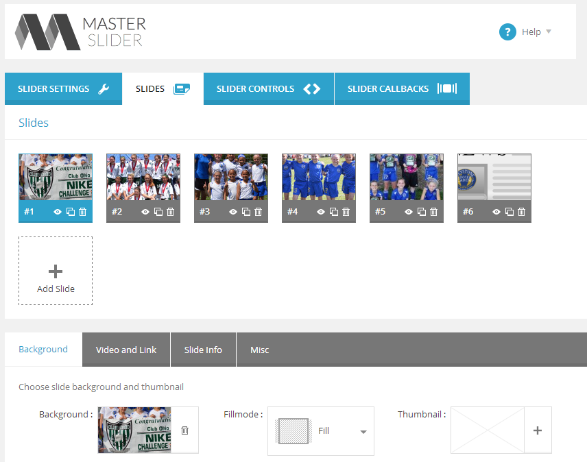

Figure 9 - Master Slider Management

1. Click on the tile labeled “*Add Slide*”.
2. You will see a blank tile appear.
3. On the “Background” tab, click the “+” icon to select or upload an image that will serve as the slide image.

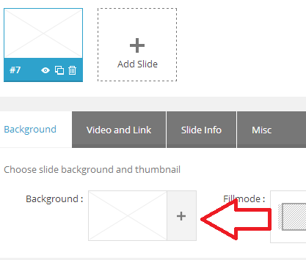

Figure 10 - Adding a slide image

1. You can select an image from the media gallery (covered in a previous section), or upload directly from your computer.
2. When complete, select “*Add Image*” from the image selection window.
3. Click the tab labeled “*Slide Info*”.
4. Enter the text you want displayed below the image when the slide is displayed on the homepage.

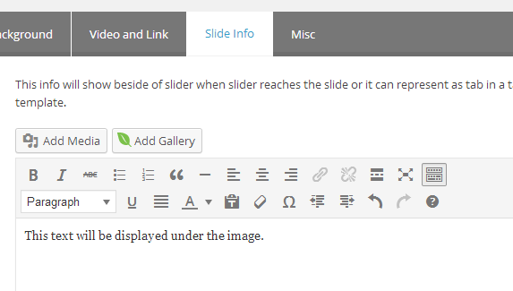

Figure 11 - Adding text to your slide

1. Scroll to the bottom of the page and click the button labeled “*Save Changes*”.

## Modifying Slides

To change an image or description of a slide, follow the steps outlined in the **Adding Slides** section, omitting steps 4 and 5 where a slide is added. Instead, click on the slide you wish to modify and continue with steps 6-11.

## Deleting Slides

1. Follow steps 1-3 from the **Adding Slides** section.
2. Click the trash icon on the slide you wish to delete as shown in Figure 12.

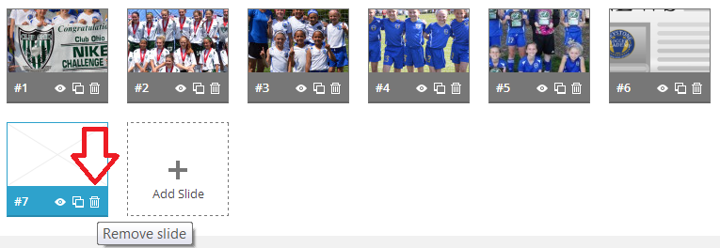

Figure 12 - Delete a slide

1. When prompted, click “OK” to confirm or “Cancel” to cancel the deletion request.
2. Scroll to the bottom of the page and click “*Save Changes*”.

# Updating the calendar (upcoming events)

Your site contains an events calendar powered by a plugin called “CalPress Events”. Upcoming events are shown on the right side of every page under the search box that links to the full event details.

## Adding Events

1. Navigate to the CalPress Events menu and click “*Add New*”

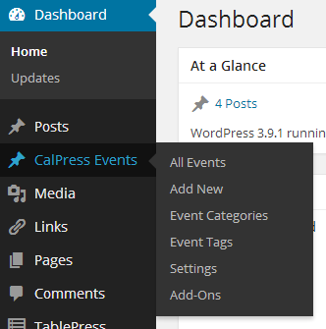

Figure 13 - Add Event Menu

1. Fill out the form with the Event title, description, and details.
2. Select “*Event*” from the list of categories on the right.
3. Click “*Publish*” to place the event on the calendar.

## Modifying Events

1. Navigate to the CalPress Events menu and click “*All Events*” as shown in Figure 13.
2. You should see a screen similar to Figure 14.

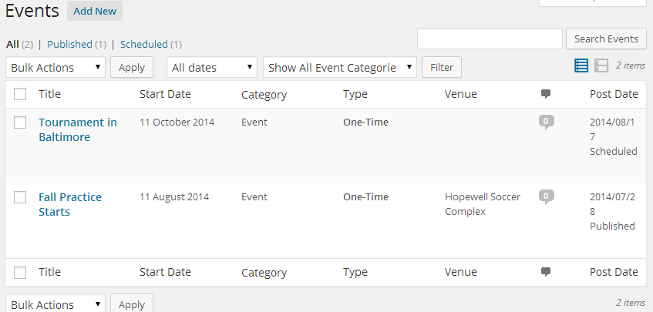

Figure 14 - View All Events

1. Select the title of the event you wish to modify.
2. Follow steps 2-4 of **Adding Events** to make the necessary changes to your event.

## Deleting Events

1. Navigate to the CalPress Events menu and click “*All Events*”.
2. Hover over the title of the event you wish to delete. You will see something like in Figure 15.

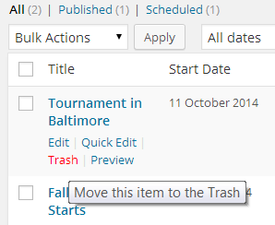

Figure 15 - Delete Event

1. Click “*Trash*” from the menu that is displayed on hover to delete the event.

# Updating announcements

Announcements appear on the right side of every page. They are displayed in the order they were added, up to 5 at a time.

## Adding Announcements

1. Navigate to the Posts menu and click “*Add New*”.

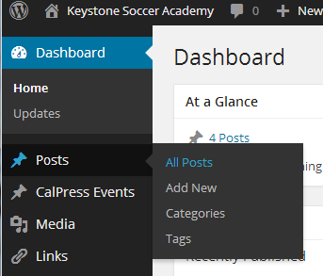

Figure 16 - Add New Post

1. Fill out the form by providing a Post title and description.
2. The description field can contain formatted text such as bold, italics, underline, colors, etc. You can even add images from the media gallery (covered in a previous section).
3. Select relevant categories from the right sidebar as shown in Figure 17.

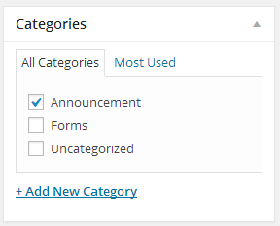

Figure 17 - Category selection

1. Click “*Publish*” from the right sidebar to complete the post creation. It will now appear in the “Announcements” section of your site.

## Modifying Announcements

1. Navigate to the Posts menu and click “*All Posts*” (see Figure 16 for image).
2. You should see a table of posts similar to Figure 18.

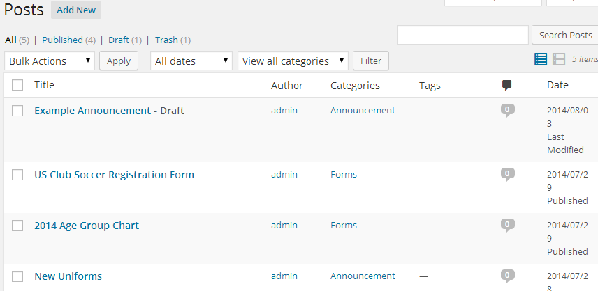

Figure 18 - Viewing posts

1. Select the post title you wish to modify.
2. Follow steps 2-5 of **Adding Announcements** to make desired changes and publish.

## Deleting Announcements

1. Navigate to the Posts menu and click “*All Posts*”.
2. Hover over the title of the post you wish to delete. You will see something like in Figure 19.

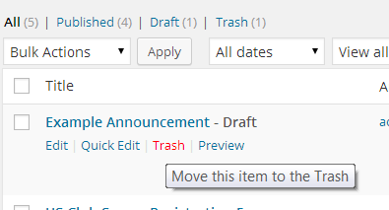

Figure 19 - Delete a post

1. Click “*Trash*” from the menu that is displayed on hover to delete the post.

# Updating Forms

Forms appear on the right side of every page. They are displayed in the order they were added, up to 5 at a time. To update forms, follow the instructions located in the **Updating announcements** section but instead of selecting the category “Announcement”, select “Forms”.

# Modifying the image galleries (photos and uniforms)

There are currently two image galleries on your website. The photo gallery is the main gallery for displaying public photos. Team pictures, action shots on the field, and any other photo you want to share with your teams (and fans!) would go there. The second gallery is a set of images showing your uniforms and apparel. The steps below outline the process for managing the galleries.

1. Navigate to the administrator menu “Envira Gallery” as shown in Figure 20.

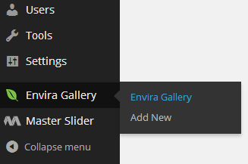

Figure 20 - Envira Gallery

1. Click on the Title field of the gallery you wish to manage.
2. You should see an interface similar to Figure 21.

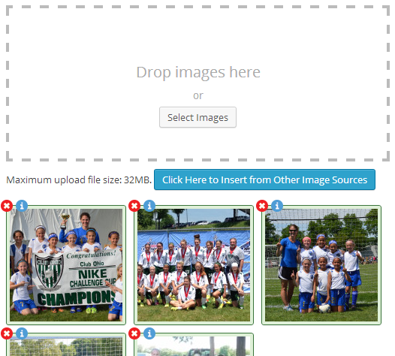

Figure 21 - Image Gallery Admin Interface

1. Drag images from your desktop in the box with a dashed line border or click the button labeled “*Select Images*” to browse your computer for them.
2. If the image is already uploaded to the site (for instance, the image was used in the news image slider covered previously in this guide), click to blue button labeled “*Click Here to Insert from Other Image Sources*” instead.
3. Your images should automatically be uploaded.
4. Drag and drop the displayed images to re-arrange them in the gallery. The order goes from top to bottom, left to right.
5. To remove an image from the gallery, click the red (x) in the corner of the image.